**Solutions Calculator Club**

**Project Documentation**

**Power Supply Circuit Function**:

This module providesPower (VCC) to the other modules. For the purpose of the capstone project this is a 5 volt DC adapted from 120 volts ac. However, when pitching this project as a tool to teach and build circuits in class this would be one of the two modules that I would set first semester course material around.

There is a schematic that follows which the student can design the PCB (Printed Circuit Board) and build it in Open Lab. There would need to be modification based on the power requirement of each student's capstone project.

The theory for this module will be built upon during the semester from ELTR-100 Network Analysis.

**Power Supply Circuit Schematic**:

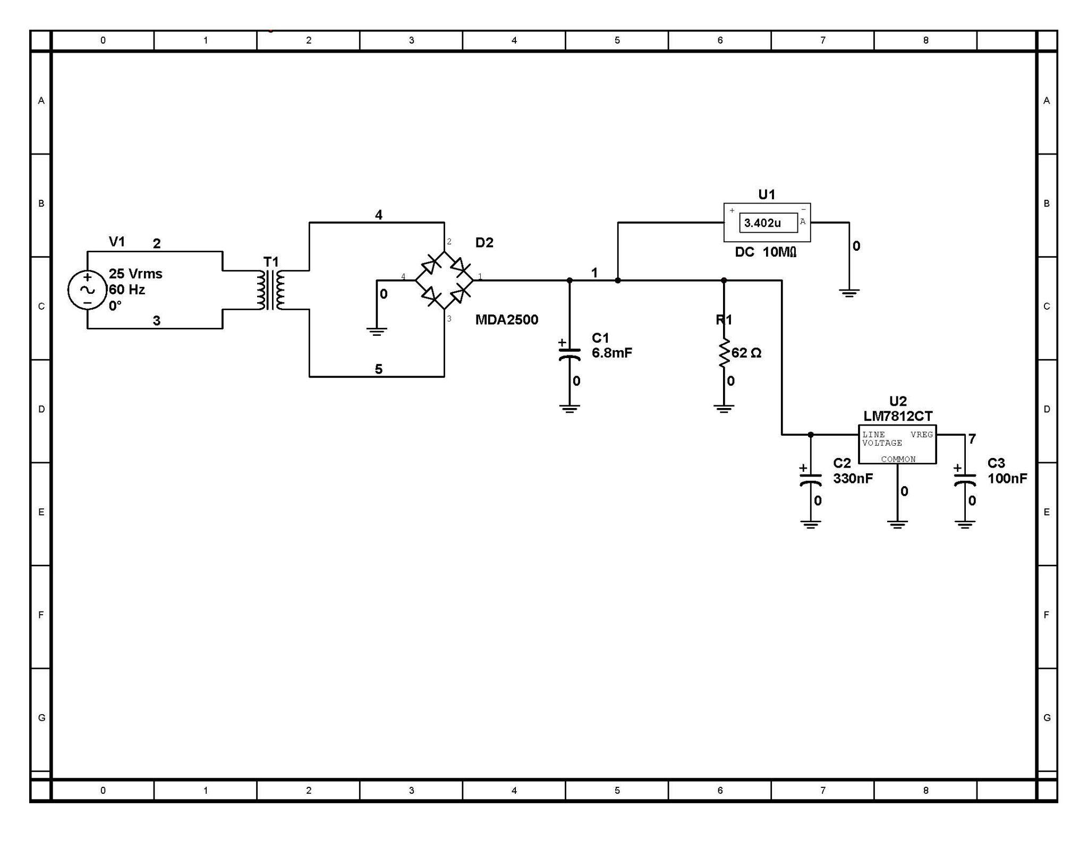

**Parts List** …………………………………………………………………………NA